Travelling Salesman Problem (TSP)
Aim:
To find the shortest route that visits all cities exactly once and returns to the starting city.
Objective:
To minimize the total travel cost or distance while visiting every city exactly one time.
Algorithm:
- Start the program.
- Input the number of cities and the distance (cost) matrix between the cities.
- Select a city as the starting point.
- Generate all possible routes that visit each city exactly once.
- Calculate the total distance (cost) for each route, including the return to the starting city.
- Compare the total cost of all possible routes.
- Select the route with the minimum total cost.
- Display the shortest route and its minimum travel cost.
- Stop the program.
PYTHON CODE:
from itertools import permutations

n = int(input("Enter the number of cities: "))

cities = list(range(n))

print("Enter the distance matrix:")

dist = []
for i in range(n):
row = list(map(int, input().split()))
dist.append(row)

min_cost = float('inf')
best_path = None

for path in permutations(cities):
cost = 0
for i in range(len(path) - 1):
cost += dist[path[i]][path[i + 1]]

# Return to starting city
cost += dist[path[-1]][path[0]]

if cost < min_cost:
min_cost = cost
best_path = path

print("\nBest Path:", best_path + (best_path[0],))
print("Minimum Cost:", min_cost)
OUTPUT:
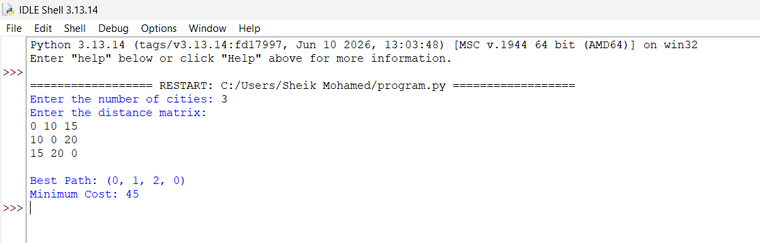

Result:
Shortest path identified.
Conclusion:
TSP helps optimize route planning.

